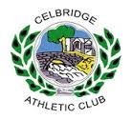
Ireland’s Fastest Feet
Athletics Initiative is coming to
Celbridge!
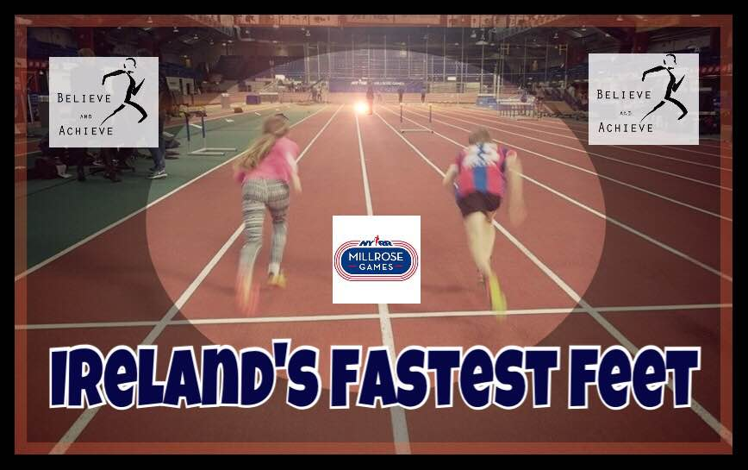
We are on the search for the speediest boys and girls in Ireland! All seven and eight year olds are encouraged to come along to The Mill, Celbridge on Saturday 29th October at 11am and see how fast your legs can move! Celbridge AC are kindly hosting one of the trials of The Fastest Feet Nationwide search for Ireland’s fastest kids.
We are calling on all schools, sports clubs and parents to encourage your children to experience something energetic and different. We want to introduce your kids and pupils to the fun and excitement of running through speed gates whilst being cheered on by their peers, teachers and coaches! We are taking this search nationwide to fire up young kids and get them excited about running and athletics!
At each testing venue we will select Ireland’s fastest feet and the semi-finalists will all be invited to an indoor development meet in the Athlone AIT arena where they will get a chance to experience the thrill or running on an indoor track in front of a packed crowd and rub shoulders with some of Ireland’s top track and field athletes. The winners of the girls and boys finals in Athlone will be flown to New York along with a parent.
Here the lucky boy and girl will be hosted by legendary runner and Irish mile record holder Ray Flynn. The highlight of their trip to New York will be a chance to run against the fastest boys and girls in New York City at the Millrose Games. This is the 110th year of the most prestigious indoor track meet on the calendar. Otherwise known as the Indoor Olympics, the meet showcases superstars of athletics, Olympic medallists, World Champions and record holders.
Last year’s winners, Darragh Fahy and Cait O’Reilly were crowned Ireland’s Fastest Feet and experienced the opportunity of a lifetime by getting to compete at the historic Millrose Games. The Irish legacy at this meet is quite significant – our own Eamonn Coughlan won the famed indoor Wanamaker mile race seven times, while Marcus O’Sullivan, Ronnie Delaney, Niall Bruton and Mark Carroll have also earned the title on several occasions. This initiative’s greater aim is to inspire kids to get involved in athletics, experience the joy of one of the most fundamental and accessible sports and eventually aim to become some of the future Irish stars of track and field.
To be eligible to participate, the child must be under 9 on the 11th of February 2017.
The journey starts here! So come along to the The Mill, Celbridge on Saturday 29th October from 11am and be part of an experience that could transform your child’s life!

