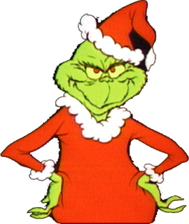
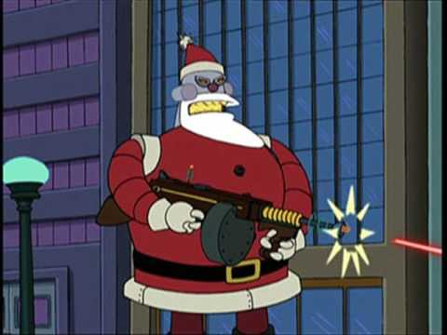
The Evil Santa
Once upon a time in Ohio, America a man named Jerry lived in a quiet neighbourhood. This man did not like Children. He thought they were rude and disgusting. Then one day a family moved in to the neighborhood. The family were the Murphy family. They lived in house 23. Jerry was outraged. The family had two kids Emily and Ciaran. They were from Ireland.
2 Months Later
It was December the time for giving and celebrating. But not for Jerry. He just wished that Santa never existed. He thought children shouldn’t get presents for free. So on Christmas night Jerry snuck into the Murphy’s house. He then stayed up all night and when then when the time was right he came out of his hiding spot and saw Santa just putting the presents under the tree. Jerry snuck up behind him and knocked him out. He then got in to Santa’s suit and put the presents back in the bag. He then went out the door and got on the sleigh and took all the presents back from the kids and decided to live in the North Pole. Next morning the kids rushed down stairs and instead of finding presents they found a naked Santa out cold. They took him to hospital.

2 YEARS LATER
The children had had enough. Two years straight they had no Christmas, so they decided to go to the North Pole to investigate. Their parents went with them. They brought walkie talkies in case somebody was responsible for this. They found Santa’s hut thanks to some friendly penguins. They entered and sitting in Santa’s chair was Jerry. The Children were shocked but got in touch with the police and they came as soon as possible. When the police eventually arrived they arrested Jerry. The kids got the key to the city and Santa took his place in the North Pole. Jerry got a life sentence in prison and the world had Christmas again.
By Sean Kiely

