Military Manoeuvres-The Forgotten Battle of Pike’s Bridge

Introduction
This picture shows children playing soldiers in Leixlip village.[1] Not so many years later and within walking distance a real battle took place with very tragic results. There were many lives lost including a past pupil from our school Anthony O’ Reilly, who was not much more than a boy .We will tell you about daring plans, failed ambushes, violent battle and terrible consequences. This is the story of the forgotten Battle of Pike’s Bridge.
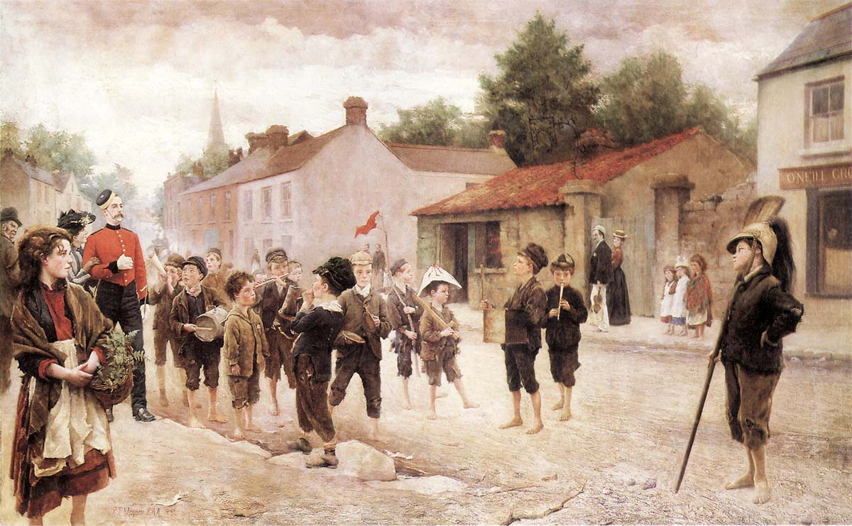

Setting the scene
The War of Independence began in 1919. The Irish used surprise attacks on British forces in Ireland, this type of warfare was called ‘guerrilla warfare’. In response the British sent over soldiers known as the Black and Tans and the Auxiliaries. The most violent day was 21st November when in retaliation for the execution of British spies and Auxiliaries, the Black and Tans fired on the crowd in Croke Park killing 14 people. In July 1921 a truce was called. In October 1921 a group, including Michael Collins and Arthur Griffith, went to London to negotiate a treaty. A treaty was signed forming an Irish Free State made up of 26 counties. Ireland would have its own army, flag and currency but would remain part of the British Empire. TDs would also have to swear allegiance to the British King.
In 1922 a Civil War began between people who supported the Treaty, led by Michael Collins and those who opposed it led by Eamon De Valera. The events in our essay took place in the villages of Leixlip and Celbridge during this Civil War.[2]

Mayhem in Kildare
The anti-treaty column in our area was led by Patrick Mullaney, a National School teacher in Leixlip. The day after the Civil War began, Mullaney was arrested and imprisoned in the Curragh. He escaped in August and took command of several brigades in the Meath and Kildare areas.[3]
Mullaney and his men blew up railway lines, bridges and cut telegraph wires so that messages couldn’t pass through. Of course they needed funding to get guns so they got it from sympathisers, collections, and holdups. They robbed post offices, mail vans and even shops. They burnt signal cabins in Leixlip, attacked Lucan Barracks, and cut telephone wires. They actually attacked and damaged bridges that they would have used themselves- Celbridge and Louisa Bridge. They attacked Celbridge Workhouse and later set it on fire. They robbed a postman of his stamps and money.[4] They left a trail of destruction throughout Kildare.
Baldonnel Aerodrome
Baldonnel was an Irish Free State Army base which held aeroplanes, cars and ammunition. It was a big target for the anti-treaty side. Mullaney had a heroic plan to take over Baldonnel, steal some planes and bomb Leinster House. He had about 30 Free State soldiers from Baldonnel working with him. According to local historian Jim Doyle, our past pupil Anthony O’Reilly played an important role in this plan, joining the Free State Army to go undercover to see what was going on. It was planned to get help from Kildare, Meath and Dublin but this did not happen
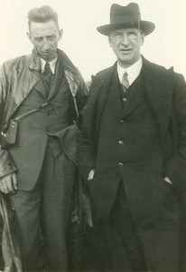
“One hundred men were promised from the Dublin Brigade but only twenty turned up” [5]
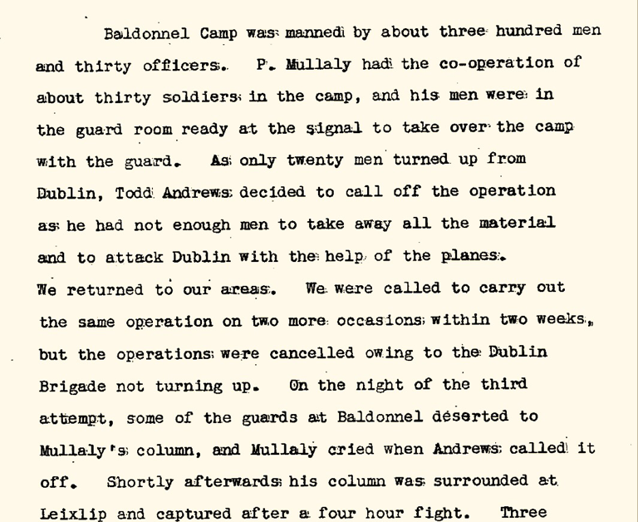
It was called off by Dublin Brigade officer Todd Andrews. It was also called off a second time by Andrews. The plan for the third attempt was to steal arms and vehicles and bomb Beggars Bush barracks. Anthony O’Reilly was ready to open the gate to let them in and two pilots were ready to steal two planes but the reinforcements from Dublin didn’t arrive so yet again Todd Andrews called it off…. Again!! Mullaney was furious and so was O’Reilly.
“On the night of the third attempt some of the guards at Baldonnel deserted to Mullaney’s column and Mullaney cried when Andrews called it off” [6]

On his way out O’Reilly stole a Lewis machine gun. [ 7]

Celbridge Men
Five of the men in Mullaney’s column were from Celbridge. They were Thomas Cardwell, John Dempsey, Thomas Kealy, Charles O’ Connor and Anthony O’ Reilly. We found their details in the 1911 census and also in old roll books from our school.
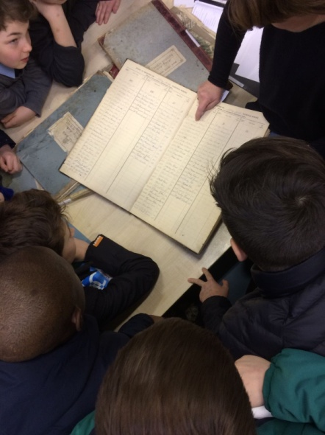

Anthony O’ Reilly was the only one of these men executed and we wanted to learn more about him. Local historian Jim Doyle has done extensive research on O’ Reilly and he came to speak to us.
Anthony O’Reilly was born on 13th June 1902. He was born in Celbridge Workhouse. His mother’s name was Bridget O’Reilly. He had a twin sister Julia Mary who died aged one due to convulsions.

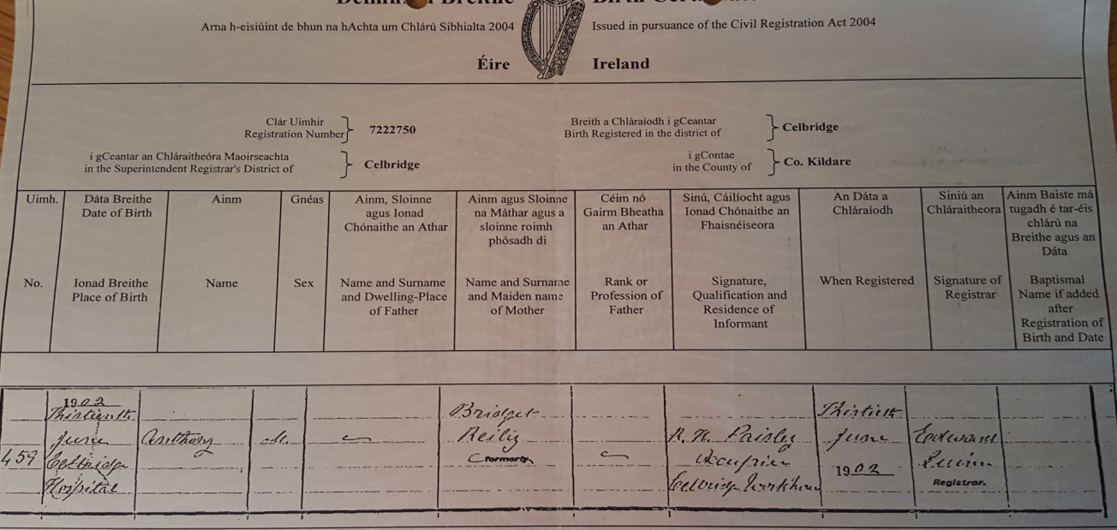 [8]
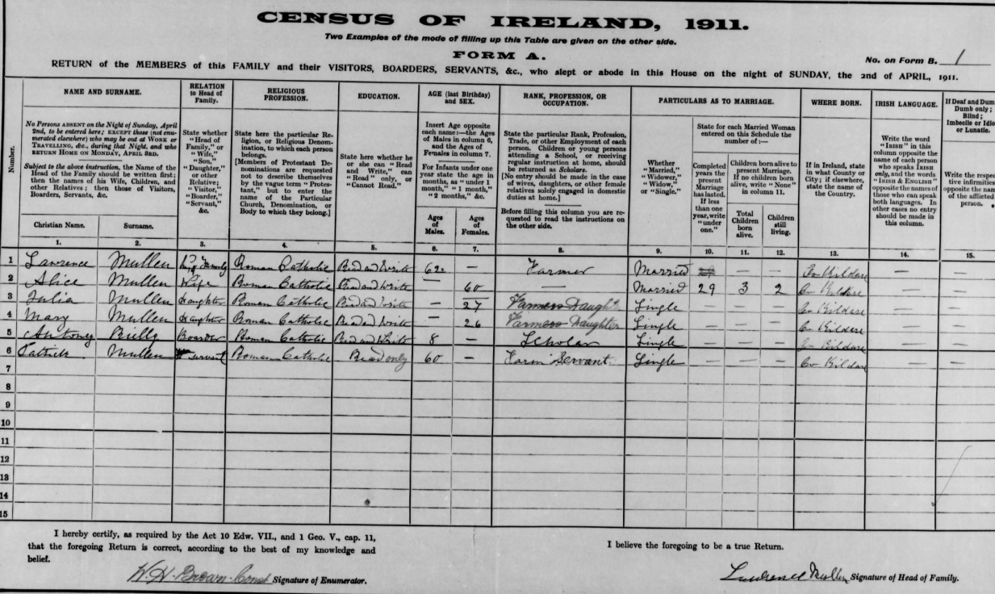
He was fostered by the Mullins family.[9 ]
He went to the Abbey National School in 1911. We can see from the roll he had regular attendance which could mean good health. The confirmation name he chose was Desmond.[10]
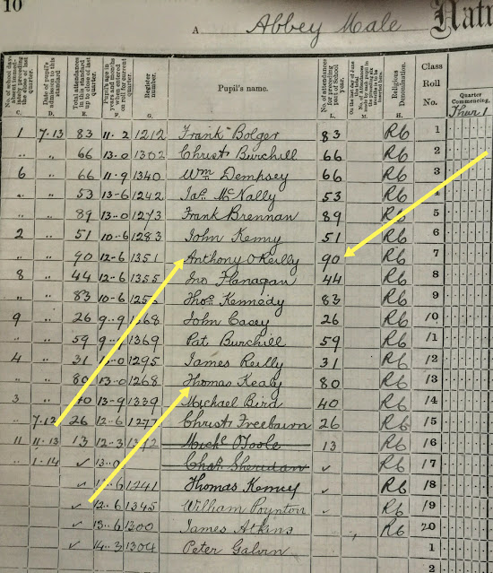

[ 11]

According to Jim Doyle, local oral accounts tell us that Anthony lived with his mother as he grew older and his nickname was the “County Boy”.
Anthony joined the IRA in his teens and was in a column led by Mullaney during the War of Independence
The Military archives provided this information:
Private Anthony O'Reilly
Service number: VR16188
Enlisted: 4th April 1922
Unit: 3rd Infantry Battalion
Previous old IRA service: member of B Company, 3rd Battalion, 1st Meath Brigade.[ 12 ]

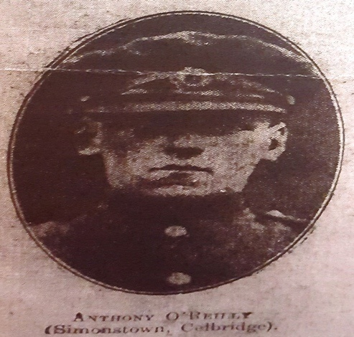

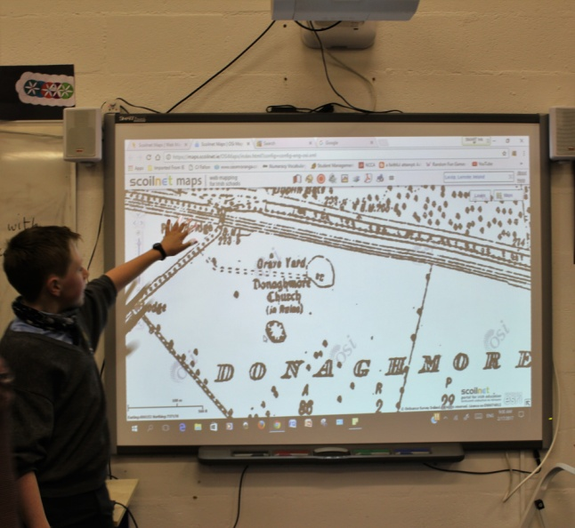
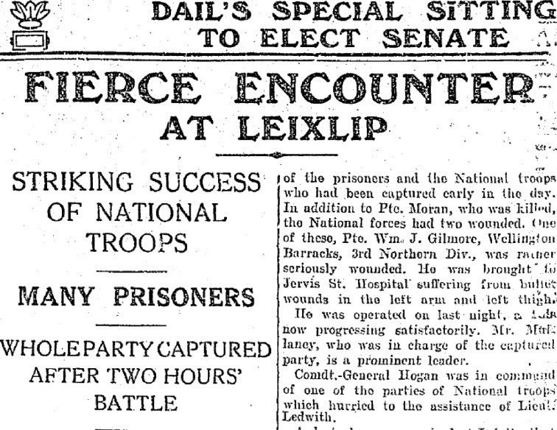

[ ]
[14] ]
[13]

